In Selenium Java, there are several types of frameworks that can be used to structure and manage test automation. Here are three common types:

**Data-Driven Framework:**

**Description:** In a data-driven framework, test data is separated from the test scripts. This allows for running the same set of test scripts with different sets of data. The data can be stored in various formats like Excel files, CSV files, databases, or other data sources.

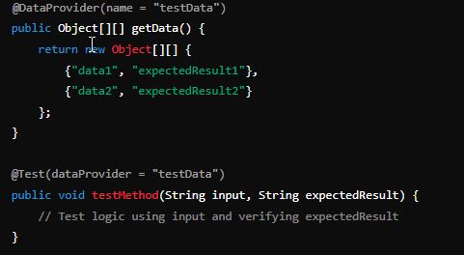

**Components:**

Test Data: Stored externally (e.g., Excel, CSV, database).

Data Provider: A method or class responsible for reading test data and supplying it to the test scripts.

Test Scripts: Scripts that use the data provider to fetch test data and execute tests accordingly.

**Advantages:**

Easy to manage and update test data without changing the test scripts.

Allows for extensive testing with multiple data sets.

**Keyword-Driven Framework:**

**Description:** A keyword-driven framework separates the test case logic from the actual test automation code. Test cases are written using keywords, which represent actions to be performed on the application under test. These keywords are mapped to functions or methods in the test scripts.

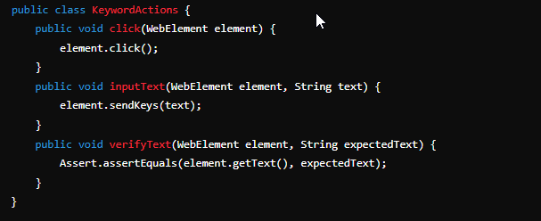

**Components:**

Keywords: Defined actions (e.g., Click, InputText, Verify) that can be understood by the framework.

Test Scripts: Implementations of the keywords.

Test Data: Often stored in Excel sheets, where each row represents a test case with a sequence of keywords and corresponding data.

**Advantages:**

Non-programmers can write test cases using predefined keywords.

Test cases are easier to read and maintain.

**Hybrid Framework:**

**Description:** A hybrid framework combines elements of both data-driven and keyword-driven frameworks, leveraging the advantages of both. It allows for more flexibility and modularity in test automation.

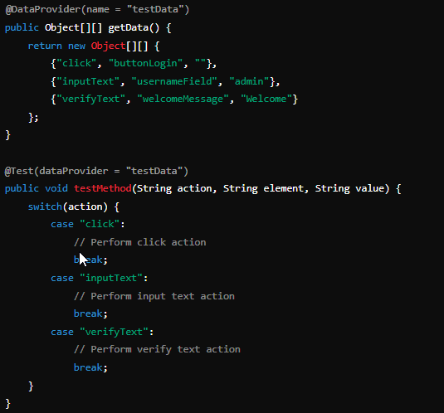

**Components:**

Combination of Data-Driven and Keyword-Driven components.

Test Data: Stored externally and used to drive test scripts.

Keywords: Used to define test actions.

Test Scripts: Utilize both data-driven and keyword-driven methodologies.

**Advantages:**

Highly flexible and adaptable to various testing needs.

Allows for comprehensive testing with both structured test data and readable test actions.